CALL FOR SUBMISSIONS:
Community engagement for inclusive rural transformation and gender equality
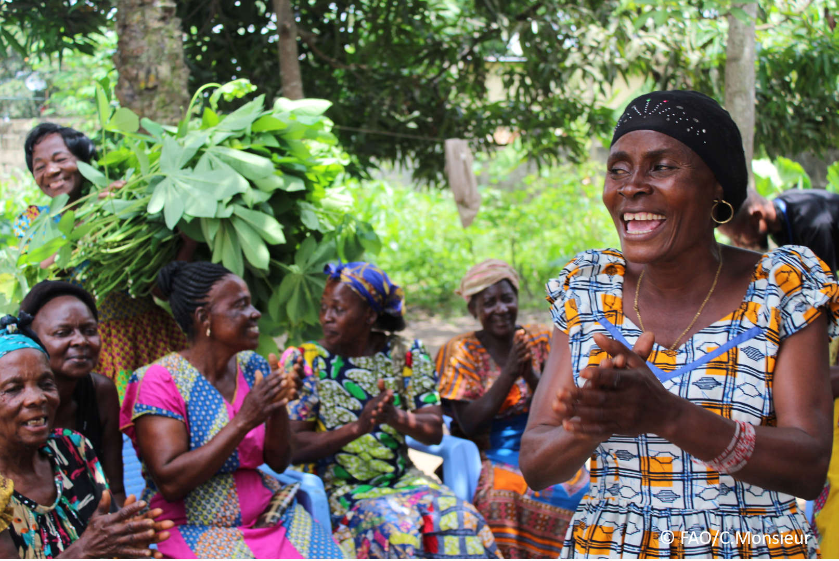
The objective of this call for submissions is to collect good practices, experiences, and lessons learnt on the use of community engagement for inclusive rural transformation and gender equality. The initiative, organized by the Rural Transformation and Gender Equality Division (ESP), seeks to gather insights from a diverse range of contributors, both within FAO and from external stakeholders. Its goal is to share knowledge, foster learning, and guide the scaling up of community engagement and community-led collective action to leave no one behind. The call builds on FAO's past efforts in this area, such as the Community Engagement Days series of webinars.
The call for submissions is open until 27 November 2024.

How to take part in this call for submissions:
To take part in this Call for submissions, please register to the FSN Forum, if you are not yet a member, or “sign in” to your account. Please review the topic note to understand the criteria we are considering for this call. If you wish to learn more about community engagement, you may refer to the background document. Once you have completed this submission template, upload it in the box “Post your contribution” on the call webpage, or, alternatively, send it to fsn-moderator@fao.org.
Please keep the length of submissions limited to 1,500 words and feel also free to attach relevant supporting materials.

Template for submissions

Contact person: | Name: Mian Muhammad Awais  Organization/Unit: Lahore University of Management Sciences, LUMS (www.lums.edu.pk)  Country: Pakistan  Email address: awais@lums.edu.pk
Name/title of the good practice | SILK-Sericulture Information and knowledge Portal: For smart geo-independent community engagement
Where is the good practice taking place? (Multiple selection allowed) | ☐ Europe and Central Asia  ☐ Latin America and the Caribbean  ☐ North Africa and Near East  ☐ Sub-Saharan Africa  x Asia and the Pacific  ☐ North America  ☐ Global
Affiliation | ☐ Farmer and producer organizations  ☐ Trade Union  ☐ Informal community-based, farmer-based or self-help group  x Research and academia  ☐ Government  ☐ Local/traditional authorities  ☐ Private Sector  ☐ Civil Society Organization  ☐ Intergovernmental Organization (e.g. UN system, World Bank)  ☐ Resource Partner/Donor  ☐ Other (please specify)
In which sector(s) and context (s) have you used this community engagement good practice? (Multiple selections allowed) | x Education  ☐ Health and Sanitation  ☐ Food production in agrifood systems (please also tick the sub-categories)  ☐ Crop cultivation  ☐ Fisheries and aquaculture production  ☐ Livestock  ☐ Forestry  ☐ Agroforestry  ☐ Horticulture  ☐ Apiculture (beekeeping)  ☐ Agroecology and sustainable farming practices  ☐ Soil and water management  ☐ Other: ____________  ☐ Post-production in agrifood systems (please also tick the sub-categories)  x Processing and value addition  ☐ Marketing and retailing  ☐ Transporting  ☐ Food loss and waste  ☐ Packaging  ☐ Storage  ☐ Distribution  ☐ Other _________  x Gender Equality  ☐ Climate Action  ☐ Citizenship and Governance  ☐ Social Protection  ☐ Humanitarian and protracted crisis  ☐ Conflict resolution, peace and resilience  x Digital innovation  ☐ Other sector (please specify) _________
Who are the financial partners supporting this good practice, if applicable? | NA
- In a few sentences, summarize your community engagement good practice.
The “SILK (Smart Sericulture Information and knowledge) System” is a community engagement initiative aimed at empowering women in rural Pakistan by leveraging technology to foster financial independence and socio-economic development. To be specific, Our community engagement good practice involves developing a web-enabled information system focused on sericulture (silkworm farming) to empower women in rural Pakistan. This platform, accessible via mobile application, provides women with tools, resources, and training to establish sustainable silkworm farming businesses. By fostering financial independence, reducing socio-economic disparities, and leveraging technology, the initiative supports women's empowerment and uplifts marginalized communities.

- What problem(s) or challenge(s) does your good practice aim to address through community engagement?
The practice aims to address the following challenges:
- Lack of Financial Independence: Women in rural Pakistan often lack opportunities for sustainable livelihoods.
- Educational Barriers: Many women are uneducated, limiting their access to traditional employment or business opportunities.
- Gender Pay Gap: The initiative addresses gender income inequality by providing women with independent income sources.
- Limited Market Access: Rural women face challenges in selling products due to the lack of efficient market connectivity.
- Socio-Economic Disparities: The project works to bridge the gap between urban and rural communities by enabling economic inclusion.

- Describe your good practice in more detail. Include the main guiding principles, the desired changes or outcomes you aim to achieve (Theory of Change), and the key phases of implementation.
Guiding Principles:
- Empowerment: Equip women with knowledge and tools to build sustainable businesses.
- Inclusivity: Design systems accessible to uneducated and marginalized women.
- Sustainability: Develop a model that transitions from free services to profit-sharing or subscription-based revenue for long-term viability.
Desired Changes/Outcomes (Theory of Change):
- Women gain financial independence and contribute to household incomes.
- Reduction in gender pay and socio-economic gaps.
- Communities benefit from improved health, education, and social services through women-led initiatives.
Key Phases of Implementation:
- Development Phase: Build the knowledge based platform and ensure information sharing and flexible accessibility.
- Pilot Phase: Offer free training and support to build trust.
- Scale Phase: Transition to a revenue-sharing or subscription model for sustainability.
- Growth Phase: Expand the platform to other agricultural domains.

- Who are the key actors and stakeholders involved in the design and implementation of the good practice, and what are their respective roles? Consider local partners, government, local authorities, community radios, civil society, research, the private sector, etc.
Local Women: Primary beneficiaries who will engage with the platform to start sericulture businesses.
Government and Local Authorities: Facilitate awareness campaigns and support policies to promote women’s inclusion in economic activities.
Microfinance Institutions and Banks: Provide loans and financial literacy programs.
Technology Partners: Develop and maintain the web and mobile applications.
Civil Society Organizations: Assist in outreach and community mobilization.
Research Institutes: Offer expertise in sericulture best practices and market analysis.
- How does your intervention ensure inclusivity and equal and meaningful participation within the community?
Describe how your intervention includes and engages different groups within the community. Consider aspects like gender, age, ethnicity, disability status, livelihoods, and other specific conditions (e.g., people living in prolonged crisis, migrants, refugees). Explain how your intervention engages diverse segments of the rural community. Highlight the specific actions or strategies you use to reach these groups. If applicable, mention if your intervention uses specific approaches such as gender-responsive, gender-transformative, intersectionality, or other methods to ensure inclusivity and gender equality.
Inclusivity Strategies:
- Gender-Responsive Design: The platform focuses specifically on uneducated and marginalized rural women.
- Local Language and Visual Aids: Simplified content in local languages ensures accessibility.
- Technology Access: Mobile-optimized design enables women with limited resources to use the application.
- Intersectionality: Special provisions for women in prolonged crises or facing disabilities.
Community Engagement Actions:
- Building community groups
- Training sessions tailored for different literacy levels.
- Collaboration with community leaders to build trust and encourage participation.
- Promoting financial inclusion by connecting women to microfinance opportunities.

- By using community engagement, what results and impacts have your good practice achieved?
Please provide specific examples and evidence demonstrating the effectiveness of your intervention, focusing on both qualitative and quantitative outcomes related to livelihoods and well-being improvements.
Case Studies in Context:
The SILK (Smart Sericulture Information and knowledge) System reflects outcomes similar to successful sericulture programs in Kokrajhar (Assam) and Karnataka, emphasizing the socio-economic and environmental benefits of sericulture when integrated with community engagement.
Key Results and Impacts:
- Improved Livelihoods: Like the sericulture practices in Assam and Karnataka, the initiative in Pakistan has enabled rural women to start silkworm farming businesses, generating stable income and creating jobs within the community. For example, in Kokrajhar, sericulture provided significant economic benefits by integrating silk into traditional crafts.
- Increased Financial Independence: Similar to Karnataka, where marginalized communities gained financial empowerment, rural women in Pakistan now contribute to household incomes, enhancing their role in financial decision-making.
- Community-Wide Economic Growth: Urban demand for silk, observed in India, also benefits rural producers in Pakistan by connecting them directly to markets through the web-enabled platform. This eliminates reliance on exploitative middlemen, increasing profits for women entrepreneurs.
- Environmental Sustainability: Like in Kokrajhar, where mulberry cultivation improved soil health and supported biodiversity, similar practices in Pakistan are creating environmentally sustainable farming ecosystems.
Quantitative Outcomes (Based on Case Study Parallels):
- Employment for multiple individuals per hectare of mulberry cultivation, as seen in India.
- Reduction in gender pay gaps and socio-economic disparities, aligning with successful empowerment models in Karnataka.
Qualitative Outcomes:
- Women report enhanced confidence and participation in household and community decisions.
- Families experience improved access to education and health services.
- Increased awareness and adoption of sustainable agricultural practices.
- Among these results, has the good practice led to improvements in terms of gender equality, women’s empowerment, and/or social inclusion?
Describe the behavioral changes in terms of gender that the good practice promotes, emphasizing agency, leadership, and participation in local governance. Include efforts to challenge discriminatory norms and unequal power dynamics. Highlight also how the intervention has supported the well-being (including psychological resilience) of marginalized groups and enhanced their inclusion and participation in decision-making processes.

Case Studies in Context:
Sericulture initiatives in Karnataka and Assam demonstrated transformative effects on gender equality, which parallels the outcomes of the Smart Sericulture Information System in Pakistan.
Improvements in Gender Equality and Empowerment:
- Agency and Leadership: Women in rural Pakistan are now assuming leadership roles in sericulture businesses, mirroring the success seen in Karnataka, where marginalized women became economically independent and socially empowered.
- Challenging Norms: Like in Assam, where women artisans integrated silk production into cultural traditions, women in Pakistan are redefining traditional gender roles by participating in economic activities and managing their own businesses.
- Social Inclusion: The platform’s inclusive approach ensures that even the most marginalized women, including those with disabilities or from minority groups, can participate and benefit.
Behavioral Changes in Gender Roles:
- Encouraging equitable participation in household decision-making.
- Increasing visibility and recognition of women as contributors to the local economy.
- Promoting women’s psychological resilience and confidence through financial independence.
Efforts to Address Discrimination:
The initiative fosters equity by addressing systemic barriers such as lack of market access and financial literacy, similar to the gender-focused sericulture programs in Karnataka.

- What key challenges did you encounter while implementing the community engagement activities, and how did you address them?
Include any resistance from communities, pushback, or issues related to unequal power dynamics, if applicable.

Case Studies in Context:
Challenges faced in Kokrajhar and Karnataka provide valuable parallels, as similar issues arose during the implementation of the Smart Sericulture Information System in Pakistan.
Key Challenges:
- Cultural Resistance: In Pakistan, deeply ingrained gender norms initially hindered women’s participation, akin to the challenges in Assam, where women artisans faced societal constraints.
- Technological Barriers: Limited access to internet and mobile devices in rural Pakistan echoed the infrastructure limitations faced in remote areas of Karnataka.
- Economic Instability: Like the market price fluctuations experienced by silkworm farmers in Kokrajhar, Pakistani sericulture businesses also faced financial uncertainties during the pilot phase.
Solutions Implemented:
- Building Trust: Engaged local leaders and influencers, similar to community-driven approaches in Assam, to advocate for women’s involvement and reduce resistance.
- Improved Accessibility: Developed offline functionality for the platform, drawing inspiration from Karnataka’s focus on adapting sericulture practices to local contexts.
- Market Stability: Partnered with buyers and market stakeholders to ensure fair prices, addressing the volatility observed in Kokrajhar’s silk markets.
- Capacity Building: Conducted training sessions to enhance financial literacy and business management skills, empowering women to handle economic uncertainties independently.

- What are the key lessons learned from your community engagement good practice?
Inclusivity is Key: Providing localized, simplified content in local languages made the platform accessible to uneducated women, ensuring participation across diverse demographics.
Trust Building is Crucial: Gaining community acceptance requires engaging local leaders and addressing cultural resistance through dialogue and awareness.
Adaptability Enhances Effectiveness: Designing the platform for low-bandwidth environments and offline functionality significantly improved its usability in remote areas.
Comprehensive Support Drives Success: Combining training, financial literacy, and market access created a holistic ecosystem for women’s empowerment.

- Has this practice been replicated in the same context or in different contexts?
What are the required conditions to replicate and adapt the practice in another context/geographical area?
Replication Status: The practice has not yet been formally replicated but has strong potential for adaptation in similar rural or underserved contexts.
Conditions for Replication:
  - Infrastructure: Ensure mobile connectivity and access to devices.
  - Cultural Context: Customize content to align with local norms and languages.
  - Institutional Support: Secure collaboration with local governments, financial institutions, and NGOs.
  - Community Trust: Establish relationships with local leaders and stakeholders for effective outreach.
  - Technology: Design the platform to accommodate low-tech environments and include offline capabilities.

- How sustainable are the results achieved by this good practice?
Describe the key elements that need to be in place to make the initiative sustainable, including enabling environment (legal and policy frameworks and institutions), local ownership, accountability, etc.
The initiative's results are designed to be sustainable through:
- Local Ownership: Women directly manage their businesses, ensuring long-term engagement and autonomy.
- Revenue Model: Transitioning to equity-based profit-sharing or subscription models provides financial sustainability for stakeholders and the platform.
- Policy Support: Collaboration with local governments ensures alignment with development frameworks and facilitates scalability.
- Institutional Partnerships: Partnerships with banks, microfinance organizations, and NGOs ensure continued support and funding opportunities.
- Capacity Building: Regular training and updates keep participants engaged and adaptive to market changes.

- Based on the conversations FAO held during the Community Engagement days, a definition of community engagement for empowerment was proposed:

“Community engagement for empowerment and community-led collective action can be defined as an inclusive and participatory process that enables community members to become active agents of change in decisions affecting their lives, health, and environment. This process develops their capacity to achieve sustainable outcomes for improved rural livelihoods. Embracing a rights-based approach, it prioritizes the agency and participation of all community members, regardless of gender identity, sexual orientation, age, ethnicity, caste, socioeconomic status, political affiliation, migration status, or ability/disability. Indeed, inclusive approaches recognize the complexities of overlapping marginalization and discrimination that can exclude different community members from decision-making processes and implement strategies to foster their participation, agency and empowerment.”

We invite you to contribute to this definition. What would you add or change? Please share your thoughts, suggestions, and any additional elements you believe are crucial for a comprehensive understanding of community engagement approaches aimed at community-led collective action for inclusive rural transformation, people’s empowerment and gender equality.
The FAO’s definition of community engagement captures the essence of inclusivity, empowerment, and participatory decision-making.
Suggested Additions:
- Emphasis on Technology: Highlight the role of digital platforms in bridging gaps and enabling access to resources in remote areas.
- Sustainability through Economic Models: Include a focus on financial mechanisms, such as microfinance or revenue-sharing, that ensure long-term viability of community-led initiatives.
- Resilience-Building: Address psychological and economic resilience as key outcomes of community engagement to strengthen marginalized groups against systemic challenges.
- Monitoring and Feedback: Integrate mechanisms for regular community feedback to adapt and improve initiatives dynamically.

- Based on your experience, what gaps or areas for improvement still need to be addressed in the field of community engagement?
- Digital Divide: Limited access to technology and the internet in remote areas restricts the scalability of digital initiatives.
- Cultural Resistance: Deeply ingrained gender norms and patriarchal attitudes pose challenges to women’s active participation.
- Financial Literacy: Many women lack the knowledge to manage finances, access loans, or handle digital transactions.
- Monitoring and Impact Assessment: Insufficient tools to measure long-term social and economic impacts of community engagement programs.
- Inclusivity for Intersectional Identities: Addressing the overlapping marginalization faced by individuals based on gender, disability, and socio-economic status requires tailored strategies.

- What do you think is FAO's role in the field of community engagement? How can FAO support and enhance interventions like yours, if applicable? Consider aspects such as policy advocacy, capacity development, funding, technical assistance, knowledge production and sharing, and fostering partnerships.
FAO’s Role:
The FAO can act as a catalyst for inclusive, sustainable community engagement by focusing on the following areas:
- Policy Advocacy: Promote policies that prioritize women’s empowerment, rural development, and digital inclusion.
- Capacity Development: Offer training and resources to build technical and financial literacy among rural populations.
- Funding and Grants: Provide seed funding for initiatives like Smart Sericulture to pilot innovative models.
- Technical Assistance: Share expertise in agricultural practices, market trends, and technology development to enhance project effectiveness.
- Knowledge Sharing: Create a platform to disseminate case studies, best practices, and research findings from successful community engagement programs.
- Fostering Partnerships: Facilitate collaborations between governments, NGOs, private sectors, and local communities to strengthen and expand initiatives.
- Monitoring and Evaluation: Develop frameworks to track progress, assess impact, and refine interventions for long-term success.
By addressing these roles, the FAO can amplify the impact of projects like Smart Sericulture and contribute to transformative rural development on a global scale.

Link(s) to specific references about your good practice (e.g. reports, communication products, videos, articles)  Kokrajhar District, Assam. (2024). Sericulture dynamics and policy suggestions.  Retrieved from http://www.socialstudiesjournal.com/archives/2024/vol6issue1/PartB/6-1-24-577.pdf  Entomology Journal. (2019). Sericulture in India: Insights and challenges.  Retrieved from https://www.entomoljournal.com/archives/2019/vol7issue6/PartS/7-4-159-562.pdf  Government of Punjab. (n.d.). Impact evaluation of development projects: A case study of project development of sericulture activities in Punjab.  Retrieved from https://dgme.punjab.gov.pk/system/files?file=Impact%20Evaluation%20Of%20Development%20Projects%20A%20Case%20Study%20Of%20Project%20Development%20Of%20Sericulturer%20Activities%20In%20Punjab.pdf  Government of Punjab. (n.d.). Evaluation report on development of sericulture activities in Punjab.  Retrieved from https://dgme.punjab.gov.pk/system/files?file=EVL-97%20Evaluation%20Report%20on%20Development%20of%20Sericulture%20of%20Activities%20in%20Punjab.pdf  ResearchGate. (n.d.). Impact evaluation of development projects: A case study of project development of sericulture activities in Punjab.  Retrieved from https://www.researchgate.net/publication/279752076_IMPACT_EVALUATION_OF_DEVELOPMENT_PROJECTS_-A_CASE_STUDY_OF_PROJECT_DEVELOPMENT_OF_SERICULTURE_ACTIVITIES_IN_PUNJAB | Please include attachment(s) or add here link(s) to documents/videos/podcasts/other with specific references.

The call for submissions is directly aligned with the thematic components of collective action within FAO's Programme Priority Areas (PPAs), specifically Better Life 1 (Gender Equality and Rural Women’s Empowerment), Better Life 2 (Inclusive Rural Transformation) and Better Life 3 (Agriculture and Food Emergencies).

